1. **Home page**

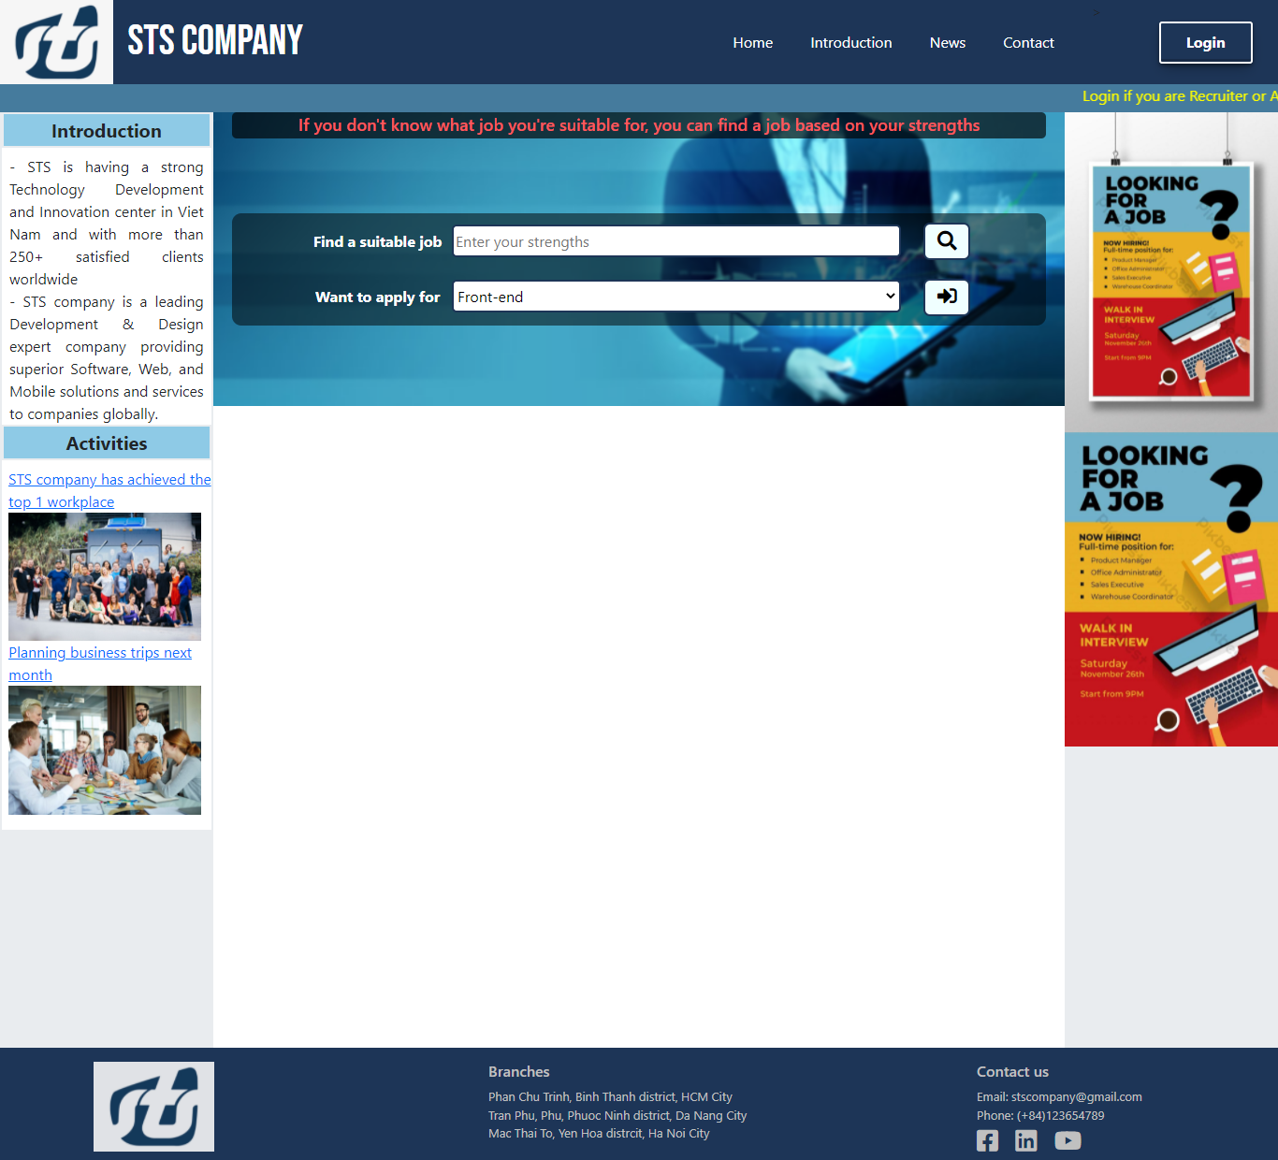

|  |  |  |  |  |
| --- | --- | --- | --- | --- |
| **Homepage** | | | | |
| **No.** | **Field name** | **Type** | **Require** | **Target** |
| 1 | Header | div | width: 100%;  height: 90px;  background-color: #1d3557;  padding: 0;  margin-top:-16px; |  |
| 2 | Logo | img | float: left;  height: 90px;  width: 10%; | STS logo |
| 3 | Company name | h1 | font-size: 45px;  color: white;  line-height: 90px;  font-family: 'Bebas Neue', cursive;  float: left; |  |
| 4 | Navigation bar | ul, li, a | ul li{  float: left;  list-style: none;  padding-right: 40px;}  a{  color: white;  text-decoration: none;} | Redirect to home, introduction, news, contact page |
| 5 | Login | a | float: right;  width: 100px;  height: 45px;  text-align: center;  line-height: 40px;  border: 2px white solid;  color: white;  font-weight: bold;  font-size: 16px;  margin-right: 2%;  margin-top: 23px;  border-radius: 3px;  text-decoration: none; | When onClick, System redirect to login page |
| 6 | Alert | marquee | background-color:#457b9d;  color: white; | Alert only recruiter or admin can login to the website |
| 7 | Introduction and Activities | div | margin: 0px -12px;  height: auto;  word-wrap: break-word;  overflow: hidden;  list-style: none;  background-color: white;  border-left: #e9ecef 2px solid; | Show introduction and activities |
| 8 | Title introduction and activities | h5 | font-weight: bold;  text-align: center;  padding: 5px;  background-color: #8ecae6;  border: #e9ecef 2px solid; |  |
| 9 | Content of introduction and activities | p | padding: 0px 8px;  text-align: justify; |  |
| 10 | Activities link | a | list-style: none;  margin-left: -25px; | View details of a specific activity |
| 11 | Activities image | img | Width: 95%; | Show image of each activity |
| 12 | Find and choose a job | div | background-image: url(../images/blurpic.png);  background-size: cover;  background-repeat: no-repeat;  height: 314px;  padding: 0px 30px;  margin: 0px -12px; | Show where candidate can find a suitable job or choose a job that they want |
| 13 | Note | h6 | margin: 0px 20px;  text-align: center;  color:#ff595e;  background: rgba(0, 0, 0, 0.664);  border-radius: 5px; | Note that if candidate don’t know what job they are suitable for, they can find a job base on their strength |
| 14 | Find and choose a job label | label | color: white;  font-weight: bold;  min-width: 150px; |  |
| 15 | Strengths field | input | width: 30em;  height: 35px;  border: white;  border-radius: 5px;  border: #1d3557 2px solid; | Find a job base on strength |
| 16 | Job select combobox | select | Same with Strengths field | Choose a job they want to apply |
| 17 | Search button | button | width: 90px;  height: 40px;  color: black;  border: #1d3557 2px solid;  background-color: white;  border-radius: 7px;  margin-left: 20px;  font-weight: bold; | When onClick, show a list of suitable job for candidate |
| 18 | Apply button | button | Same with Search button | When onClick, redirect candidate to job application page |
| 19 | Advertising photo | img | src="../images/side1.jpg"  src="../images/side2.jpg"  width: 100%; | Display recruitment ads |

1. **Footer**

|  |  |  |  |  |
| --- | --- | --- | --- | --- |
| **Footer** | | | | |
| **No.** | **Field name** | **Type** | **Require** | **Target** |
| 1 | footer | div | width: 100%;  height: 120px;  clear: both;  background-color: #1d3557;  display: flex;  position: relative; |  |
| 2 | Logo | Img | width: 40%;  opacity: 0.9; | STS logo |
| 3 | Footer col (Logo, Branches, Contact us) | div | color: silver;  font-size: 13px;  flex: 1;  padding-top: 15px;  padding-left: 100px; |  |
| 4 | Footer text | h6, ul, li, a | padding-left: 0;  color: silver;  list-style: none;  text-decoration: none;  position: absolute; |  |
| 5 | Footer Icon | fa-facebook-square  fa-linkedin  fa-youtube | margin-top: -10px;  color: silver;  list-style: none;  text-decoration: none; | Redirect to STS facebook, STS youtube and STS linkedin |

1. Apply for job

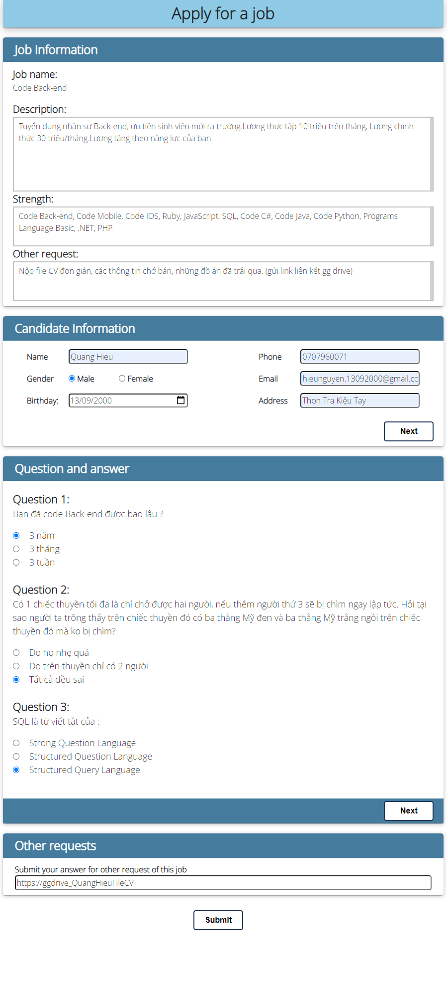

|  |  |  |  |  |
| --- | --- | --- | --- | --- |
| **Apply for job** | | | | |
| **No.** | **Field name** | **Type** | **Require** | **Target** |
| 1 | Title | h2 | background-color: #8ecae6;  padding:10px 0px;  text-align: center;  font-weight: bold;  border-radius: 5px; |  |
| 2 | Job information | div | margin-top: 20px;  border-radius: 5px;  box-shadow: |  |
| 3 | Title of elements (job, candidate, question and answer, other request) | h4 | padding: 10px 0px;  margin: 0 auto;  padding-left: 1em;  font-weight: bold;  background-color:#457b9d;  color: white;  border-radius: 5px 5px 0px 0px; |  |
| 4 | Job information label | label | font-size: 20px;  font-weight: bold; |  |
| 5 | Job information content | p tag | width: 100%;  overflow-y: scroll;  border: 2px silver solid;  padding: 5px 10px; |  |
| 6 | Candidate information | div | display: flex;  justify-content: space-between;  padding: 10px 0px; |  |
| 7 | Candidate information label | label | width: 5em;  margin: 10px 0px;  font-weight: bold; |  |
| 8 | Candidate information input | input | border-radius: 5px;  width: 15em; |  |
| 9 | Next button | button | display: flex;  justify-content: flex-end;  width: 100px;  height: 40px;  background-color: #2a6f97;  font-weight: bold;  color: #FFFFFF;  border-radius: 5px;  font-size: 16px;  border-color: white;  align-items: center;  padding: 0px;  margin-right: 20px; | When onClick, go to next step of apply for a job |
| 10 | Question and answer | div | padding: 20px; |  |
| 11 | Question number | span | font-size: 22px;  font-weight: bold; |  |
| 12 | Question text | p tag | font-size: 18px !important; |  |
| 13 | Answer label | label | font-size: 18px;  margin-left: 20px; |  |
| 14 | Answer input | input type radio | default |  |
| 15 | Request label | label | font-weight: bold; |  |
| 16 | Request input | input | width: 100%;  border-radius: 5px; |  |
| 17 | Submit button | button | Same with next button | Submit the application |

1. **Login**

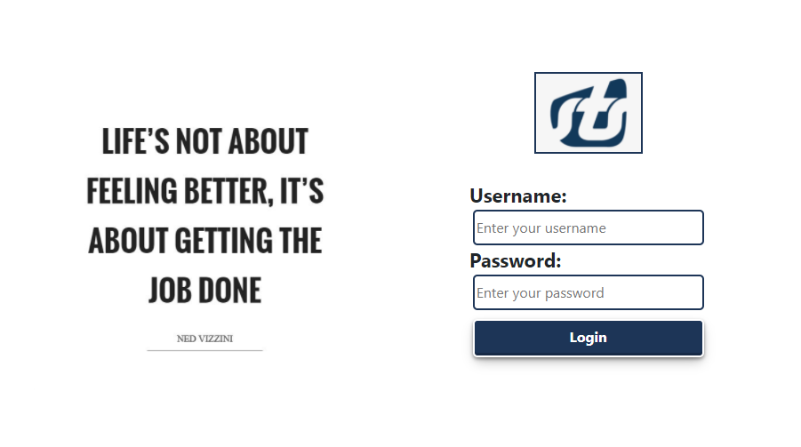

|  |  |  |  |  |
| --- | --- | --- | --- | --- |
| **Login** | | | | |
| **No.** | **Field name** | **Type** | **Require** | **Target** |
| 1 | Slogan | img | width: 100%; |  |
| 2 | Logo | img | width: 30%;  border: #1d3557 2px solid;  margin: 30px 0px; | STS logo |
| 3 | Username and password label | label | font-weight: bold;  display: inline-block;  float: left;  margin-left: 70px;  clear: left;  font-size: 22px; |  |
| 4 | Username and password input | input | min-width: 260px;  border: #1d3557 2px solid;  border-radius:5px;  height: 40px; | Enter username and password |
| 5 | Login button | Button | margin-top: 10px;  background-color: #1d3557;  width: 260px;  height: 43px;  display: inline-block;  border-radius: 5px;  text-decoration: none;  text-align: center;  line-height: 35px;  border: 2px white solid;  color: white;  font-weight: bold;  font-size: 16px;  align-items: center; | When onClick, check information and login to the system |

1. **Recruiter Homepage**

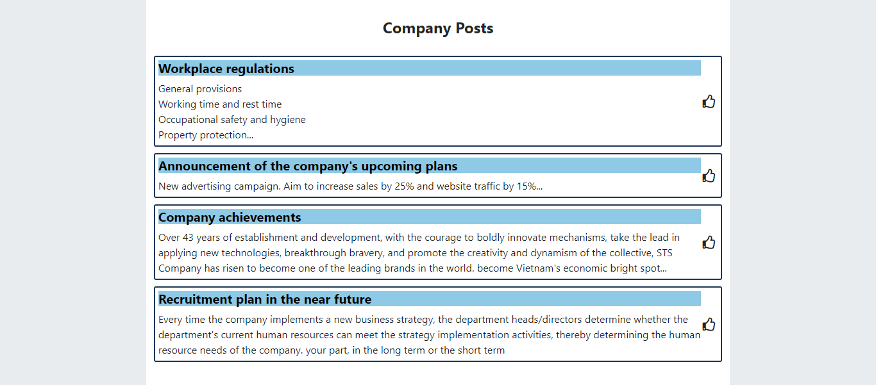

|  |  |  |  |  |
| --- | --- | --- | --- | --- |
| **Recruiter Homepage** | | | | |
| **No.** | **Field name** | **Type** | **Require** | **Target** |
| 1 | Title | h4 | text-align: center;  font-weight: bold;  margin: 30px 0px; |  |
| 2 | Wrapper posts | div | display: grid;  grid-gap: 10px; |  |
| 3 | Posts | div | border-radius: 3px;  border: #1d3557 2px solid;  padding: 5px;  display: grid;  grid-template-columns: 97% 3%;  cursor: pointer; |  |
| 4 | Posts title | h5 | color: black;  font-weight: bold;  background-color: #8ecae6; |  |
| 5 | Like icon | fa-thumbs-up | grid-column: 2/3;  grid-row: 1/3;  cursor: pointer;  justify-self: center;  align-self: center; |  |

1. **Manage Job**

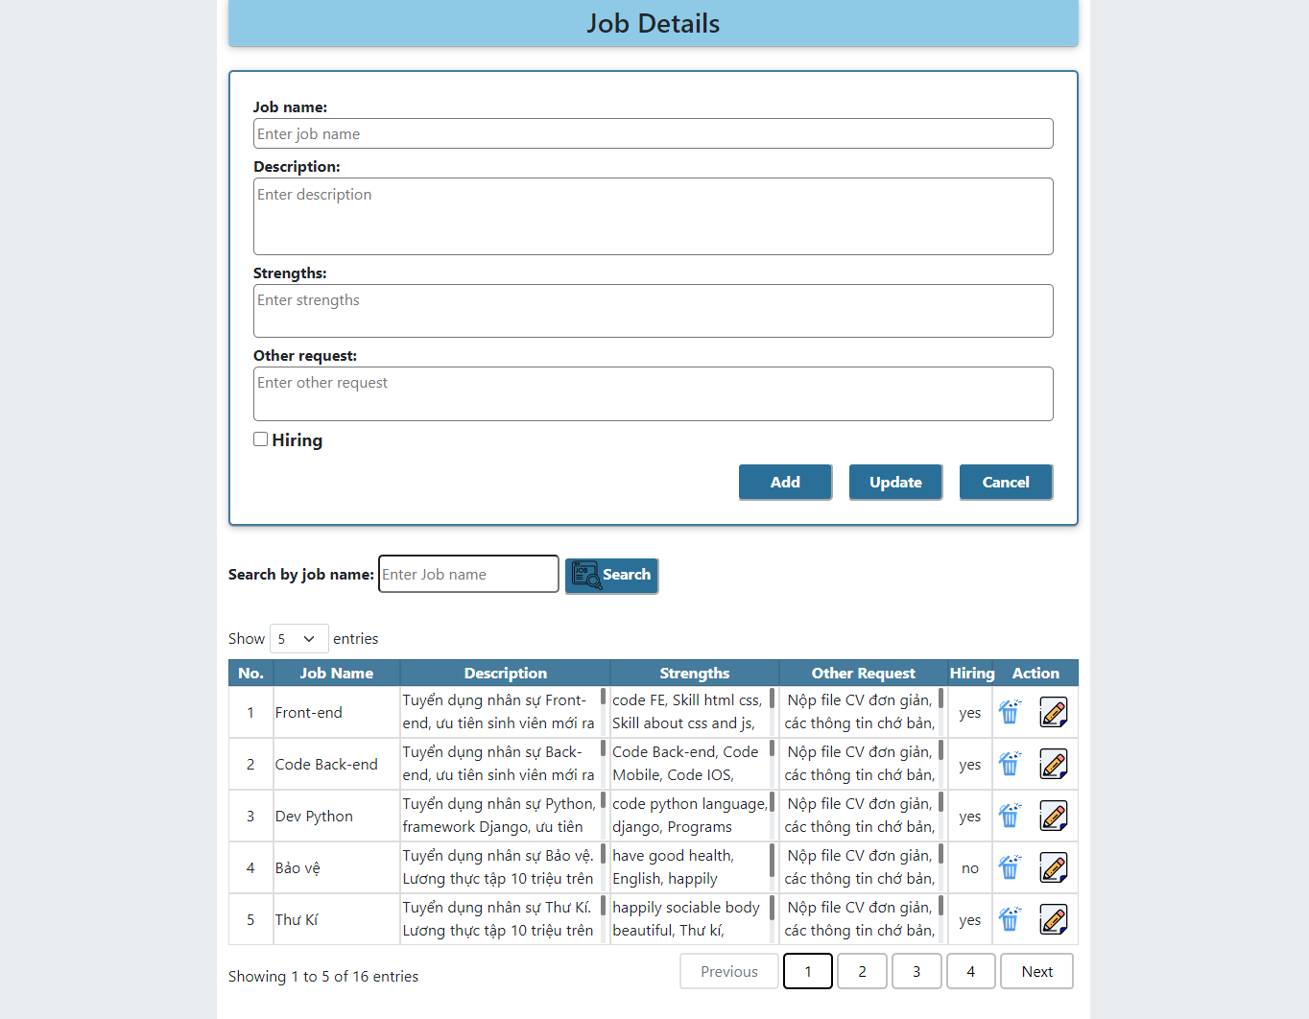

|  |  |  |  |  |
| --- | --- | --- | --- | --- |
| **Manage jobs** | | | | |
| **No.** | **Field name** | **Type** | **Require** | **Target** |
| 1 | Title | h3 tag | width: 100%;  height: 50px;  text-align: center;  background-color: #8ecae6;  border-radius: 0px 0px 5px 5px; | Display Manage Job title |
| 2 | Job detail | div | margin: 25px 0px;  border-radius: 5px;  border: #457b9d 2px solid;  padding: 1.5em; | Manage job |
| 3 | Job details label | label | font-size: 16px;  font-weight: bold; |  |
| 4 | Text field | textarea | width: 100%;  border-radius: 5px;  padding: 0.2em; | Enter name, description, strengths, other request |
| 5 | Hiring | checkbox | width: 15px;  height: 15px; | Choose on hiring or not |
| 6 | Management button | button | width: 100px;  height: 40px;  background-color: #2a6f97;  font-weight: bold;  color: #FFFFFF;  border-radius: 5px;  font-size: 16px;  border-color: white;  align-items: center;  padding: 0px; | When onClick, Add new job, Update new information for the job or Cancel: don’t change anything |
| 7 | Search label | label | font-size: 16px;  font-weight: bold; |  |
| 8 | Search field | input | border: #1d3557 2px solid; |  |
| 9 | Search button | button | Same with Manage button | When onClick search by name of job in the job table |
| 10 | Job table | table | width: 100%; | Show a list of job |
| 11 | Table header cell | th | border: 0.5px rgba(0, 0, 0, 0.397) solid;  background-color: #457b9d;  color: white;  text-align: center; | Header of the table |
| 12 | Table cells | td | border: 1px silver solid;  height: 50px;  overflow-y: scroll;  overflow-x: hidden; | Show details of each job in the table |
| 12 | Table pagintion | Jquery dataTable | **Custom:**  ordering: false,  searching: false,  lengthMenu:[[5,10,15,20,-1],[5,10,15,20,"All"]],  **Style**:  color: black;  border: 2px silver solid;  margin: 0px 5px;  border-radius: 5px;  padding: 5px 20px; | Pagination for table |

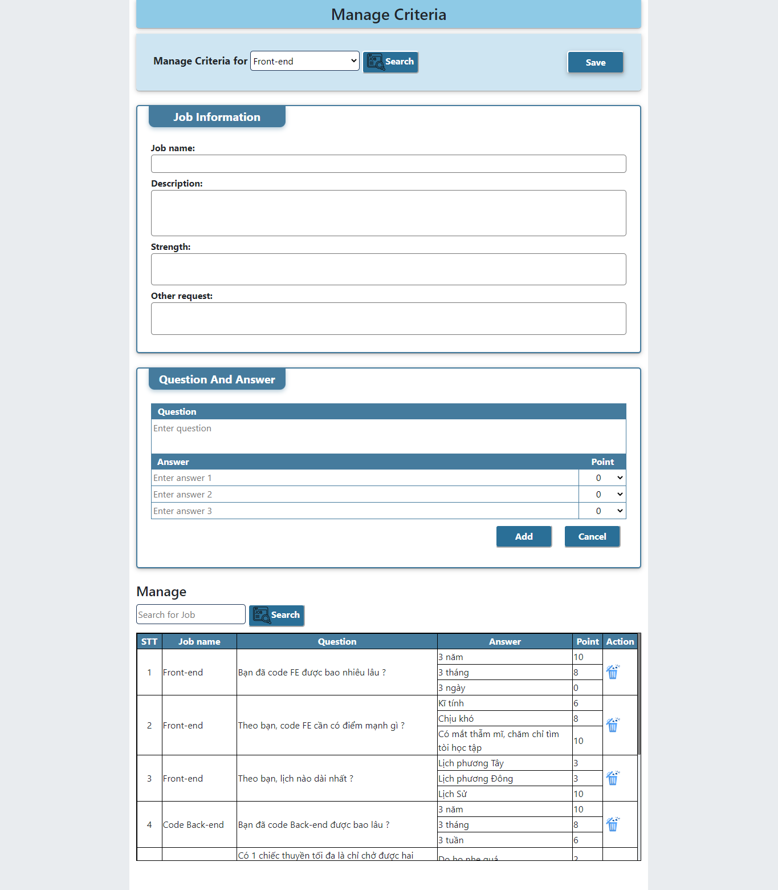

|  |  |  |  |  |
| --- | --- | --- | --- | --- |
| **Manage criteria** | | | | |
| **No.** | **Field name** | **Type** | **Require** | **Target** |
| 1 | Title | h3 tag | width: 100%;  height: 50px;  text-align: center;  background-color: #8ecae6;  border-radius: 0px 0px 5px 5px; | Display criteria title |
| 2 | Choose a job label | label | font-size: 18px;  font-weight: bold; |  |
| 3 | Choose a job combobox | select | border: #1d3557 1.5px solid;  width: 12em;  height: 35px;  border-radius: 5px;  background-color: #fff; |  |
| 4 | Search job button | button | width: 100px;  height: 40px;  background-color: #2a6f97;  font-weight: bold;  color: #FFFFFF;  border-radius: 5px;  font-size: 16px;  border-color: white;  align-items: center;  padding: 0px; | When onClick, Manage recruitment criteria for chosen job |
| 5 | Save button | button | Same with Search button | When onClick, Save all change in recruitment criteria |
| 6 | Job information | div | margin: 25px 0px;  border-radius: 5px;  border: #457b9d 2px solid; |  |
| 6 | Title of elements{  Job information, Question and answer) | h5 | width: 12em;  text-align: center;  padding: 7px;  border-radius: 0px 0px 10px 10px;  margin: 0px 1em;  margin-top: -1px;  font-weight: bold;  background-color: #457b9d;  color: white;  box-shadow: #457b9d67 0px 3px 8px; |  |
| 7 | Job information label | label | font-size: 16px;  font-weight: bold; |  |
| 8 | Job information input | Input | width: 100%;  border-radius: 5px;  padding: 0.2em; |  |
| 9 | Question and Answer table | table | padding: 1.5em;  width: 100%; |  |
| 10 | Q&A Table header cell | th | background-color: #457b9d;  border: 1px #457b9d solid;  color: white; |  |
| 11 | Q&A Table cells | td | border: 1px #457b9d solid; |  |
| 12 | Q&A Table Point row | select | Form 0 -> 10 point |  |
| 12 | Search question | input | Same with Choose a job combobox | Search by question name |
| 13 | Search question button | button | Same with Search job button | When onClick, show that question with answer and point |
| 14 | Manage Q&A table | table | width: 100%;  height: 300px;  border: 1px black solid;  overflow-y: scroll; |  |
| 15 | Manage Q&A header cell | th | background-color: #457b9d;  border: 1px black solid;  color: white; |  |
| 16 | Manage Q&A cells | td | border: 1px black solid; |  |
| 17 | Action row | img | thungrac1.png |  |